

**Assessment 3: Case study analysis (decision modelling)**

**Action Plan**

Author: Bertocco Thomas-Killian - #13758322

Lecturer: Eddie Chng

CO5124 Data Analysis and Decision Modelling | SP52 | 2019

26 September 2019

Table of Contents

Introduction 3

Task 1: The Standard Clubhouse golf course model 4

Decision Model – Linear Optimization Model 4

Define the decision variables 4

Identify the objective function 4

Determine the constraints 4

Excel Table Structure 6

Excel Solver configuration 6

Solver Results 7

Task 2: The Exclusive Clubhouse golf course model 8

Decision Model – Linear Optimization Model 8

Define the decision variables 8

Identify the objective function 8

Determine the constraints 8

Excel Table Structure 10

Excel Solver configuration 10

Solver Results 11

Option 1: Reduce the size of the exclusive clubhouse 12

Option 2: Reduce the construction cost of the exclusive clubhouse 12

Option 3: Increase the budget allocation 15

# Introduction

Cunningham Holding management is planning to build a new golf course with a standard clubhouse. The objective of this course is to maximize the enjoyment of the players. The budget of the project is $20 million, and the golf club size must be between 36 and 42 hectares. Also, it is planned to be 18-hole course. This design includes six types of holes: Straight Par 5, Dogleg Par 5, Straight Par 4, Long Par 3, and Short Par 3.

However, the shareholders would like to build an exclusive clubhouse instead of the standard clubhouse. The exclusive clubhouse has different characteristics (cost, size, enjoyability index). We will have to see the possibilities of both cases.

If it is not possible to find a possible solution with the exclusive clubhouse case, we are allowed to modify its size, its cost, and the total budget.

For every case, the objective of the new design is to maximize the enjoyability index.

# Task 1: The Standard Clubhouse golf course model

## Decision Model – Linear Optimization Model

### Define the decision variables

The decision variables are:

|  |  |
| --- | --- |
| SP5 | Straight Par 5 |
| DP5 | Dogleg Par 5 |
| SP4 | Straight Par 4 |
| DP4 | Dogleg Par 4 |
| LP3 | Long Par 3 |
| SP3 | Short Par 3 |
| SCH | Standard Clubhouse |

### Identify the objective function

In this case, the objective is to determine the highest enjoyment index possible for a standard clubhouse.

Objective function - Maximize the Enjoyment Index:

2*SP5 + 1.5*DP5 + 1.5*SP4 + 2*DP4 + 1.75*LP3 + 2.25*SP3 + 0*SCH

### Determine the constraints

The constraints are:

* Number of SP5 – 1 or more
* Number of DP5 – 1 or more
* Number of SP4 – 2 or more
* Number of DP4 – 2 or more
* Number of LP3 – 1 or more
* Number of SP3 – 1 or more
* Number of Par 5 – 4 or less
* Number of Par 4 – 14 or less
* Number of Par 3 – 4 or less
* Total Par – between 70 and 72
* Total Number of holes – exactly 18
* Total acreage – between 36 and 42
* Total Cost – $20,000,000 or less
* SP5, DP5, SP4, DP4, LP3, SP3 – must be integers

**Mathematical interpretation of the constraints**

|  |  |
| --- | --- |
| **Description** | **Function** |
| Minimum Number of SP5 | SP5 >= 1 |
| Minimum Number of DP5 | DP5 >= 1 |
| Minimum Number of SP4 | SP4 >= 2 |
| Minimum Number of DP4 | DP4 >= 2 |
| Minimum Number of LP3 | LP3 >= 1 |
| Minimum Number of SP3 | SP3 >= 1 |
| Maximum Number of Par 5 | SP5 + DP5 <= 4 |
| Maximum Number of Par 4 | SP4 + DP4 <= 14 |
| Maximum Number of Par 3 | LP3 + SP3 <= 4 |
| Minimum Total Par | 5*SP5 + 5*DP5 + 4*SP4 + 4*DP4 + 3*LP3 + 3*SP3 >= 70 |
| Maximum Total Par | 5*SP5 + 5*DP5 + 4*SP4 + 4*DP4 + 3*LP3 + 3*SP3 <= 72 |
| Total Number of holes | SP5 + DP5 + SP4 + DP4 + LP3 + SP3 = 18 |
| Total acreage | 3*SP5 + 3.5+DP5 + 2*SP4 + 2.5*DP4 + 1*LP3 + 0.75*SP3 + 2*SCH >= 36 |
| Total acreage | 3*SP5 + 3.5+DP5 + 2*SP4 + 2.5*DP4 + 1*LP3 + 0.75*SP3 + 2*SCH <= 42 |
| Total Cost | 1000000*SP5 + 1500000*DP5 + 750000*SP4 + 900000*DP4 + 600000*LP3 + 650000*SP3 + 3500000*SCH <= 20000000 |
| SP5, DP5, SP4, DP4, LP3, SP3 | SP5 = integer, DP5 = integer, SP4 = integer, DP4 = integer, LP3 = integer, SP3 = integer |

### Excel Table Structure

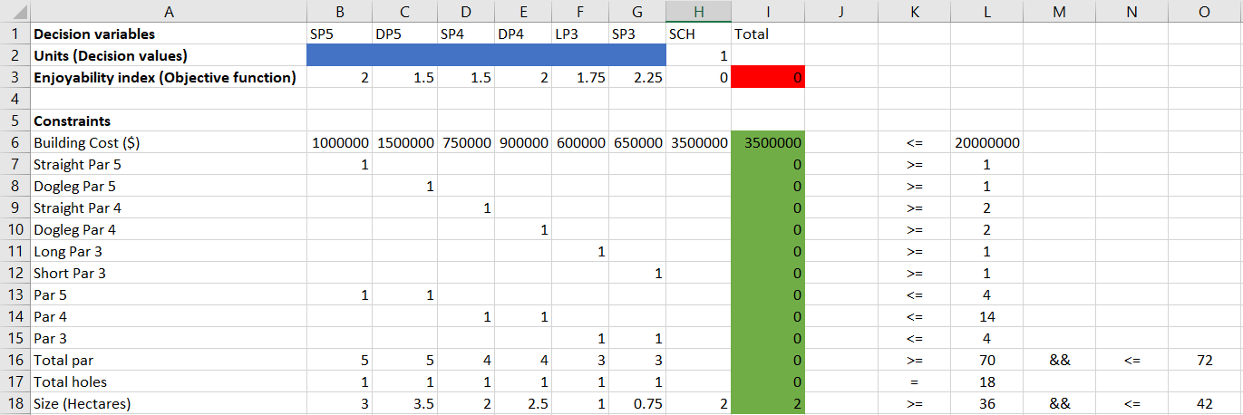

### Excel Solver configuration

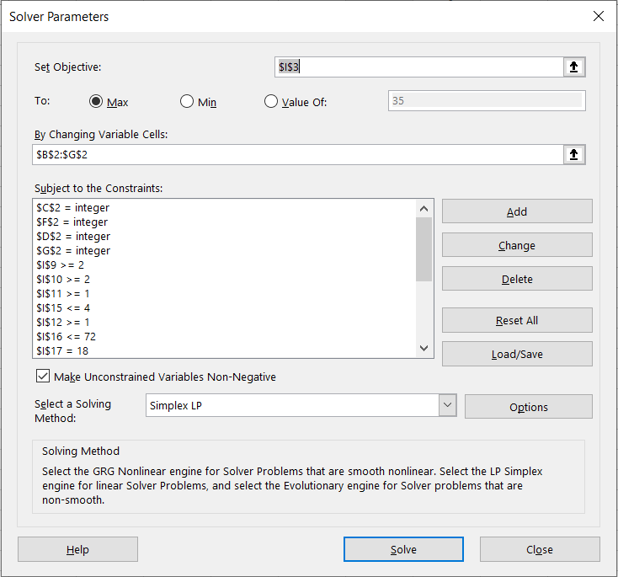

**Set Objective** [ the red cell on the screenshot ]: Maximize the Enjoyment Index (2*SP5 + 1.5*DP5 + 1.5*SP4 + 2*DP4 + 1.75*LP3 + 2.25*SP3 + 0*CH).

**Changing Variables Cells** [ blue cells on the screenshot ]: Decision values (SP5, DP5, SP4, DP4, LP3, SP3).

**Subject to the Constraints** [ green cells on the screenshot ]: add all the constraints previously determined.

**Make Unconstrained Variables Non-Negative**: Yes.

**Solving Method**: Simplex LP.

### Solver Results

**Results**: The solver has found a solution

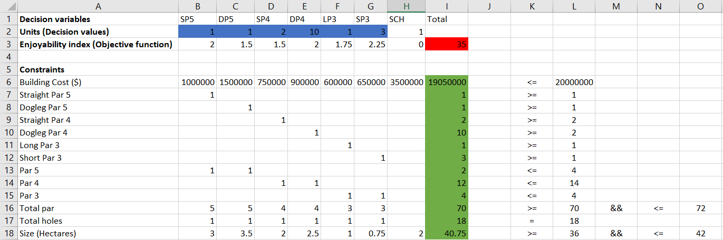

Based on the solver results, the new golf course with a standard clubhouse will contain:

* 1 Straight Par 5 hole
* 1 Dogleg Par 5 hole
* 2 Straight Par 4 hole
* 10 Dogleg Par 4 hole
* 1 Long Par 3 hole
* 3 Small Par 3 hole

The total enjoyment index of this solution is 35.

The total land that would be used in building this golf course is 40.75 hectares. This is more than the minimum size (36ha) and less than the maximum authorized (42ha).

The total cost to build this new golf course is $19,050,000. This is less than the maximum budget ($20,000,000).

# Task 2: The Exclusive Clubhouse golf course model

## Decision Model – Linear Optimization Model

### Define the decision variables

The decision variables are:

|  |  |
| --- | --- |
| SP5 | Straight Par 5 |
| DP5 | Dogleg Par 5 |
| SP4 | Straight Par 4 |
| DP4 | Dogleg Par 4 |
| LP3 | Long Par 3 |
| SP3 | Short Par 3 |
| ECH | Exclusive Clubhouse |

### Identify the objective function

In this case, the objective is to determine the highest enjoyment index possible for an exclusive clubhouse.

Objective function - Maximize the Enjoyment Index:

2*SP5 + 1.5*DP5 + 1.5*SP4 + 2*DP4 + 1.75*LP3 + 2.25*SP3 + 4*ECH

### Determine the constraints

The constraints are:

* Number of SP5 – 1 or more
* Number of DP5 – 1 or more
* Number of SP4 – 2 or more
* Number of DP4 – 2 or more
* Number of LP3 – 1 or more
* Number of SP3 – 1 or more
* Number of Par 5 – 4 or less
* Number of Par 4 – 14 or less
* Number of Par 3 – 4 or less
* Total Par – between 70 and 72
* Total Number of holes – exactly 18
* Total acreage – between 36 and 42
* Total Cost – $20,000,000 or less
* SP5, DP5, SP4, DP4, LP3, SP3 – must be integers

**Mathematical interpretation of the constraints**

|  |  |
| --- | --- |
| **Description** | **Function** |
| Minimum Number of SP5 | SP5 >= 1 |
| Minimum Number of DP5 | DP5 >= 1 |
| Minimum Number of SP4 | SP4 >= 2 |
| Minimum Number of DP4 | DP4 >= 2 |
| Minimum Number of LP3 | LP3 >= 1 |
| Minimum Number of SP3 | SP3 >= 1 |
| Maximum Number of Par 5 | SP5 + DP5 <= 4 |
| Maximum Number of Par 4 | SP4 + DP4 <= 14 |
| Maximum Number of Par 3 | LP3 + SP3 <= 4 |
| Minimum Total Par | 5*SP5 + 5*DP5 + 4*SP4 + 4*DP4 + 3*LP3 + 3*SP3 >= 70 |
| Maximum Total Par | 5*SP5 + 5*DP5 + 4*SP4 + 4*DP4 + 3*LP3 + 3*SP3 <= 72 |
| Total Number of holes | SP5 + DP5 + SP4 + DP4 + LP3 + SP3 = 18 |
| Total acreage | 3*SP5 + 3.5+DP5 + 2*SP4 + 2.5*DP4 + 1*LP3 + 0.75*SP3 + 4*ECH >= 36 |
| Total acreage | 3*SP5 + 3.5+DP5 + 2*SP4 + 2.5*DP4 + 1*LP3 + 0.75*SP3 + 4*ECH <= 42 |
| Total Cost | 1000000*SP5 + 1500000*DP5 + 750000*SP4 + 900000*DP4 + 600000*LP3 + 650000*SP3 + 6000000*ECH <= 20000000 |
| SP5, DP5, SP4, DP4, LP3, SP3 | SP5 = integer, DP5 = integer, SP4 = integer, DP4 = integer, LP3 = integer, SP3 = integer |

### Excel Table Structure

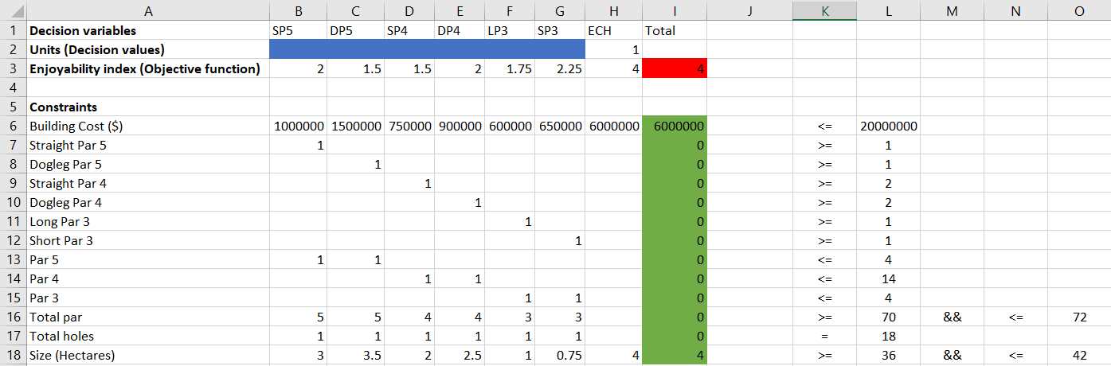

### Excel Solver configuration

**Set Objective** [ the red cell on the screenshot ]: Maximize the Enjoyment Index (2*SP5 + 1.5*DP5 + 1.5*SP4 + 2*DP4 + 1.75*LP3 + 2.25*SP3 + 0*CH).

**Changing Variables Cells** [ blue cells on the screenshot ]: Decision values (SP5, DP5, SP4, DP4, LP3, SP3).

**Subject to the Constraints** [ green cells on the screenshot ]: add all the constraints previously determined.

**Make Unconstrained Variables Non-Negative**: Yes.

**Solving Method**: Simplex LP.

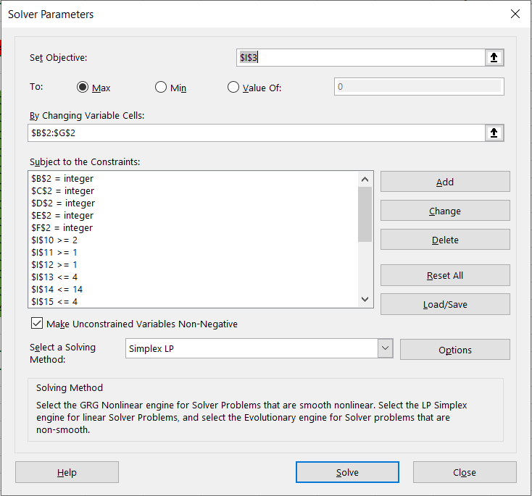

### Solver Results

**Results**: The solver was not able to find a solution.

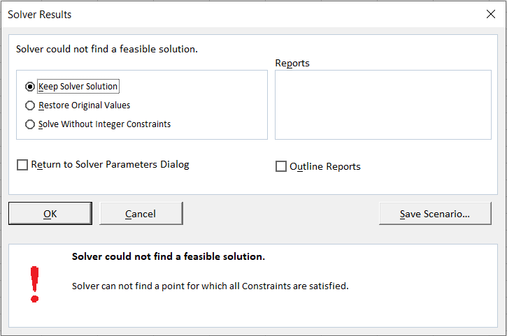

### Option 1: Reduce the size of the exclusive clubhouse

According to the subject, the size of the exclusive clubhouse must be larger than the size of a standard clubhouse ( > 2ha ).

To maximize our chance to find a solution, we will try the smallest value possible. We modify the size of the exclusive clubhouse to 2.01ha (cell H18 on the screenshot).

**Results**: The solver was not able to find a solution.



### Option 2: Reduce the construction cost of the exclusive clubhouse

#### Solution 1 – find the lowest cost possible

According to the subject, the cost of the exclusive clubhouse must be higher than the cost of a standard clubhouse ( > $3,500,000 ).

To maximize our chance to find a solution, we will try the smallest value possible. We modify the cost of the exclusive clubhouse to $3,500,000.01 (cell H6 on the screenshot).

**Results**: The solver has found a solution

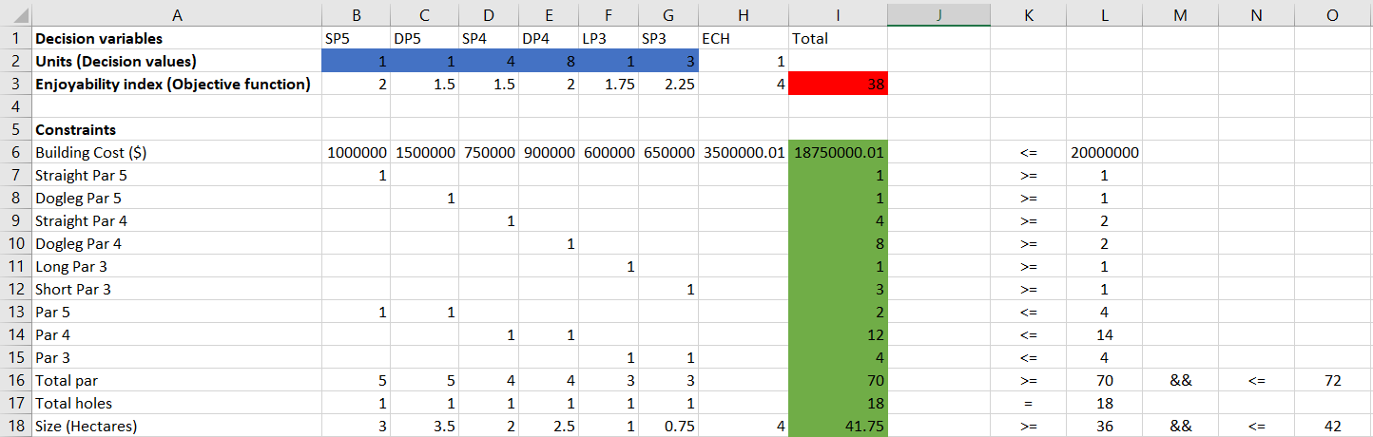

Based on the solver results, the new golf course with an exclusive clubhouse will contain:

* 1 Straight Par 5 hole
* 1 Dogleg Par 5 hole
* 4 Straight Par 4 hole
* 8 Dogleg Par 4 hole
* 1 Long Par 3 hole
* 3 Small Par 3 hole

The total enjoyment index of this solution is 38.

The total land that would be used in building this golf course is 41.75 hectares. This is more than the minimum size (36ha) and less than the maximum authorized (42ha).

The total cost to build this new golf course is $18,750,000.01. This is $1,249,999.99 less than the maximum budget ($20,000,000).

The cost of the exclusive clubhouse is $3,500,000.01, this is $2,499,999.99 less than the initial cost.

#### Solution 2 - find the highest cost possible

To find the solution with the highest cost possible, we will try to change the ECH cost value to different values.

**Try number 1**: decrease the ECH cost value to 5750000.

**Results**: The solver has found a solution

**Try number 2**: decrease the ECH cost value to 5750000.01.

**Results**: The solver was not able to find a solution.

From these two tries, we can conclude that the highest cost possible of the ECH for this plan is $5,750,000 (-$250000 compared to the initial cost).

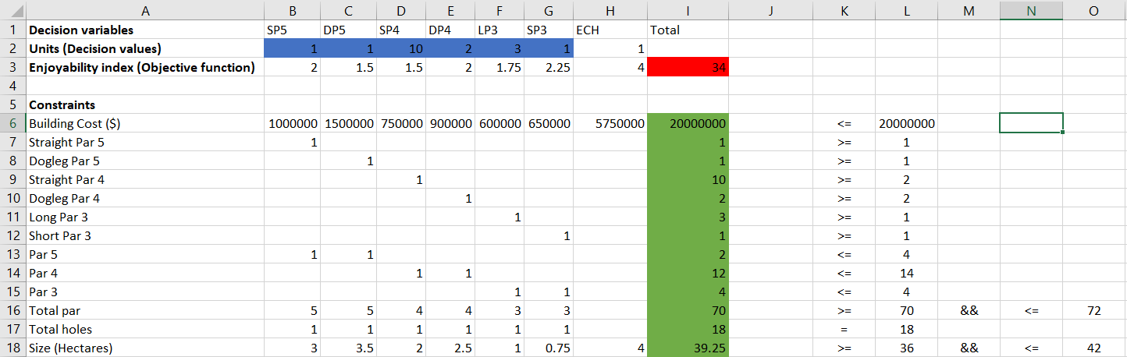

Based on the solver results, the new golf course with an exclusive clubhouse will contain:

* 1 Straight Par 5 hole
* 1 Dogleg Par 5 hole
* 10 Straight Par 4 hole
* 2 Dogleg Par 4 hole
* 3 Long Par 3 hole
* 1 Small Par 3 hole

The total enjoyment index of this solution is 34.

The total land that would be used in building this golf course is 39.25 hectares. This is more than the minimum size (36ha) and less than the maximum authorized (42ha).

The total cost to build this new golf course is $20,000,000. This is exactly the maximum budget ($20,000,000).

The cost of the exclusive clubhouse is $5,750,000, this is $250,000 less than the initial cost.

#### Summary of the two solutions for option 2

|  |  |  |
| --- | --- | --- |
|  | Solution 1 | Solution 2 |
| New cost | $3,500,000.01 | +$5,750,000 |
| Cost variance | -$2,499,999.99 | -$250,000 |
| Enjoyability Index | 38 | 34 |

### Option 3: Increase the budget allocation

#### Solution 1 – find the highest budget possible

To find a solution, we will not impose a budget limit. We remove budget constraint (1000000*SP5 + 1500000*DP5 + 750000*SP4 + 900000*DP4 + 600000*LP3 + 650000*SP3 + 6000000*ECH <= 20000000).

**Results**: The solver has found a solution

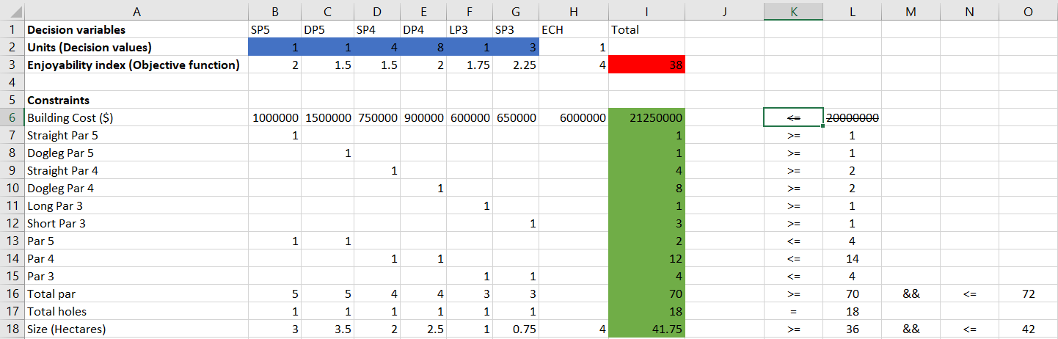

Based on the solver results, the new golf course with an exclusive clubhouse will contain:

* 1 Straight Par 5 hole
* 1 Dogleg Par 5 hole
* 4 Straight Par 4 hole
* 8 Dogleg Par 4 hole
* 1 Long Par 3 hole
* 3 Small Par 3 hole

The total enjoyment index of this solution is 38.

The total land that would be used in building this golf course is 41.75 hectares. This is more than the minimum size (36ha) and less than the maximum authorized (42ha).

The total cost to build this new golf course is $21,250,000. This is $1,250,000 more than the maximum budget ($20,000,000).

#### Solution 2 – find the lowest budget possible

**NOTE:** Based on the results of the Option 2 – Solution 2, we could already conclude that the lowest budget possible is: initial budget + $250,000 = $20,250,000.

To find the solution with the smallest budget possible, we will try to change the budget constraint to different values.

**Try number 1**: raise the budget constraint to 20250000 (1000000*SP5 + 1500000*DP5 + 750000*SP4 + 900000*DP4 + 600000*LP3 + 650000*SP3 + 6000000*ECH <= 20250000).

**Results**: The solver has found a solution

**Try number 2**: raise the budget constraint to 20249999.99 (1000000*SP5 + 1500000*DP5 + 750000*SP4 + 900000*DP4 + 600000*LP3 + 650000*SP3 + 6000000*ECH <= 20249999.99).

**Results**: The solver was not able to find a solution.

From these two tries, we can conclude that the minimum budget for this plan is $20250000 (+$250000 compared to the initial budget).

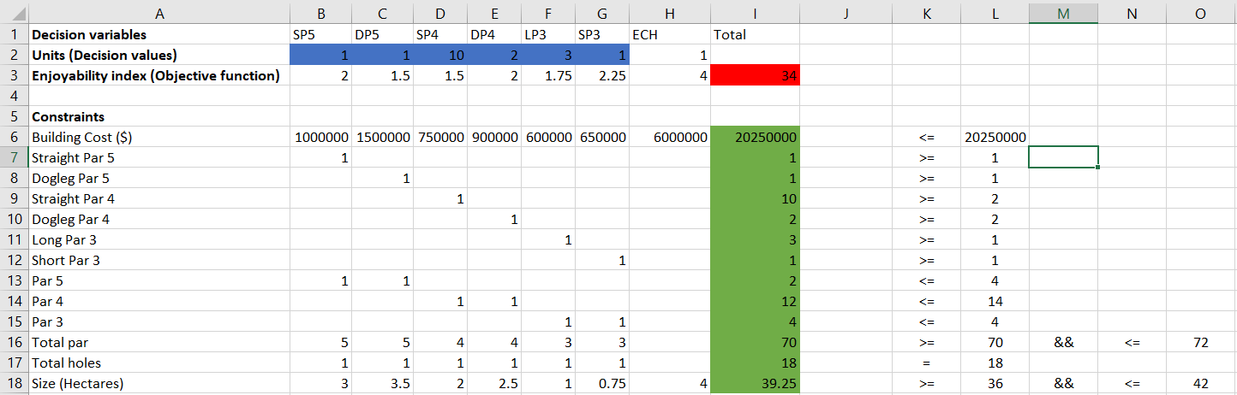

Based on the solver results, the new golf course with an exclusive clubhouse will contain:

* 1 Straight Par 5 hole
* 1 Dogleg Par 5 hole
* 10 Straight Par 4 hole
* 2 Dogleg Par 4 hole
* 3 Long Par 3 hole
* 1 Small Par 3 hole

The total enjoyment index of this solution is 34.

The total land that would be used in building this golf course is 39.25 hectares. This is more than the minimum size (36ha) and less than the maximum authorized (42ha).

The total cost to build this new golf course is $20,250,000. This is $250,000 more than the maximum budget ($20,000,000).

#### Summary of the two solutions for option 3

|  |  |  |
| --- | --- | --- |
|  | Solution 1 | Solution 2 |
| New Budget | $21,250,000 | +$20,250,000 |
| Budget variance | +$1,250,000 | +$250,000 |
| Enjoyability Index | 38 | 34 |



**Assessment 3: Case study analysis (decision modelling)**

**Report**

Author: Bertocco Thomas-Killian - #13758322

Lecturer: Eddie Chng

CO5124 Data Analysis and Decision Modelling | SP52 | 2019

26 September 2019

Table of Contents

Introduction 3

The Standard Clubhouse golf course model 4

The initial model 4

The procedure 4

Conclusion 4

The Exclusive Clubhouse golf course model 5

The initial model 5

The procedure 5

Conclusion 5

Option 1: Reduce the size of the exclusive clubhouse 5

The procedure 5

Conclusion 5

Option 2: Reduce the construction cost of the exclusive clubhouse 5

Solution 1 – find the lowest cost possible 5

The procedure 5

Conclusion 6

Solution 2 - find the highest cost possible 6

The procedure 6

Conclusion 6

Option 3: Increase the budget allocation 7

Solution 1 – find the highest budget possible 7

The procedure 7

Conclusion 7

Solution 2 – find the lowest budget possible 8

The procedure 8

Conclusion 8

Conclusion 9

# Introduction

Cunningham Holding management is planning to build a new golf course with a standard clubhouse.

However, the shareholders would like to build an exclusive clubhouse instead of the standard clubhouse. The exclusive clubhouse has different characteristics (cost, size, enjoyability index).

For every case, the objective of the new design is to maximize the enjoyability index.

This report presents the solutions found for each of the two plans and proposes alternative solutions if the initial objective is not achievable. It describes the procedure used and the results.

A reminder of constraints:

* At least one straight Par 5
* At least one dogleg Par 5
* At least two straight Par 4
* At least two dogleg Par 4
* At least one long Par 3
* At least one short Par 3
* No more than 4 Par 5
* No more than 14 Par 4
* No more than 4 Par 3
* The total par must be between 70 and 72
* The total number of holes must be precisely 18
* The total acreage must be between 36 and 42 hectares
* The total cost must be less or equal than $20,000,000 (budget)

# The Standard Clubhouse golf course model

## The initial model

### The procedure

We defined the decision variables, the objective function, and the constraints. Then, we built a table on excel and configured the solver with the constraints, the objective, and the decision values.

### Conclusion

For this plan, the solver has found a solution. The new golf course should contain:

* 1 Straight Par 5 hole
* 1 Dogleg Par 5 hole
* 2 Straight Par 4 hole
* 10 Dogleg Par 4 hole
* 1 Long Par 3 hole
* 3 Small Par 3 hole
* 1 Standard Clubhouse

The total land that would be used in building this golf course is 40.75 hectares. This is more than the minimum size (36ha) and less than the maximum authorized (42ha).

The total cost to build this new golf course is $19,050,000. This is less than the maximum budget ($20,000,000).

With this configuration, we respect all the constraints, and the total enjoyment index of this solution is 35.

# The Exclusive Clubhouse golf course model

## The initial model

### The procedure

We defined the decision variables, the objective function, and the constraints. Then, we built a table on excel and configured the solver with the constraints, the objective, and the decision values.

### Conclusion

For this plan, the solver has not found any solutions.

However, we are allowed to modify three characteristics of this model:

* Option 1 - reduce the size of the exclusive clubhouse
* Option 2 - Reduce the construction cost of the exclusive clubhouse
* Option 3 – Increase the budget allocation hypothetically

We will try every option to list all the possibilities, and let the company decides which one is the best.

## Option 1: Reduce the size of the exclusive clubhouse

### The procedure

We use the same configuration and the same table as the initial model. The only parameter that changes is the size of the exclusive clubhouse. We are only allowed to set a value between 2.01ha and 4ha. To see if there is at least one solution, we set the value to the minimum (2.01ha).

### Conclusion

The solver has not found any solutions.

If the solver has not been able to find a solution with the smallest possible value (2.01ha), it means that there are no solutions with this option.

## Option 2: Reduce the construction cost of the exclusive clubhouse

### Solution 1 – find the lowest cost possible

### The procedure

We use the same configuration and the same table as the initial model. The only parameter that changes is the cost of the exclusive clubhouse. We are only allowed to set a value higher than the cost of a standard clubhouse ( > $3,500,000 ). To see if there is at least one solution, we set the exclusive clubhouse cost value to the lowest value ($3,500,000.01).

### Conclusion

For this plan, the solver has found a solution. The new golf course should contain:

* 1 Straight Par 5 hole
* 1 Dogleg Par 5 hole
* 4 Straight Par 4 hole
* 8 Dogleg Par 4 hole
* 1 Long Par 3 hole
* 3 Small Par 3 hole
* 1 Exclusive Clubhouse

The total land that would be used in building this golf course is 41.75 hectares. This is more than the minimum size (36ha) and less than the maximum authorized (42ha).

The total cost to build this new golf course is $18,750,000.01. This is less than the maximum budget ($20,000,000).

With this configuration, we respect all the constraints, and the total enjoyment index of this solution is 38.

We can conclude that $3,500,000.01 is the lowest price to find a solution for option 2.

### Solution 2 - find the highest cost possible

### The procedure

We use the same configuration and the same table as the initial model. The only parameter that changes is the cost of the exclusive clubhouse. We are only allowed to set a value higher than the cost of a standard clubhouse ( > $3,500,000 ). To find the solution with the highest cost possible, we will try to change the exclusive clubhouse cost value to different values.

For the first try, we decrease the ECH cost value to 5750000.

**Results**: The solver has found a solution

For the second try, we decrease the ECH cost value to 5750000.01.

**Results**: The solver was not able to find a solution.

**The highest cost possible of the ECH for this plan is $5,750,000.**

### Conclusion

For this plan, the solver has found a solution. The new golf course should contain:

* 1 Straight Par 5 hole
* 1 Dogleg Par 5 hole
* 10 Straight Par 4 hole
* 2 Dogleg Par 4 hole
* 3 Long Par 3 hole
* 1 Small Par 3 hole
* 1 Exclusive Clubhouse

The total land that would be used in building this golf course is 39.25 hectares. This is more than the minimum size (36ha) and less than the maximum authorized (42ha).

The total cost to build this new golf course is $20,000,000. This is precisely the maximum budget ($20,000,000).

With this configuration, we respect all the constraints, and the total enjoyment index of this solution is 34.

From these two tries, we can conclude that the highest cost possible of the ECH for this plan is $5,750,000 (-$250000 compared to the initial cost).

## Option 3: Increase the budget allocation

### Solution 1 – find the highest budget possible

### The procedure

We use the same configuration and the same table as the initial model. The only parameter that changes is the total budget. We are only allowed to change the budget parameter to find a solution. To see if there is at least one solution, we remove the budget constraint.

### Conclusion

For this plan, the solver has found a solution. The new golf course should contain:

* 1 Straight Par 5 hole
* 1 Dogleg Par 5 hole
* 4 Straight Par 4 hole
* 8 Dogleg Par 4 hole
* 1 Long Par 3 hole
* 3 Small Par 3 hole
* 1 Exclusive Clubhouse

The total land that would be used in building this golf course is 41.75 hectares. This is more than the minimum size (36ha) and less than the maximum authorized (42ha).

The total cost to build this new golf course is $21,250,000. This is $1,250,000 more than the maximum budget ($20,000,000).

With this configuration, we respect all the constraints, and the total enjoyment index of this solution is 38.

We can conclude that $21,250,000 is the highest budget to find a solution for option 3.

### Solution 2 – find the lowest budget possible

### The procedure

**NOTE:** Based on the results of Option 2 – Solution 2, we could already conclude that the lowest budget possible is: initial budget + $250,000 = $20,250,000.

We use the same configuration and the same table as the initial model. The only parameter that changes is the total budget. We are only allowed to change the budget parameter to find a solution. To see if there is at least one solution, we will try to change the budget constraint to different values.

For the first try, we raise the budget constraint to $20,250,000.

**Results**: The solver has found a solution

For the second try, we raise the budget constraint to $20,249,999.99.

**Results**: The solver was not able to find a solution.

**The minimum budget for this plan is $20250000.**

### Conclusion

For this plan, the solver has found a solution. The new golf course should contain:

* 1 Straight Par 5 hole
* 1 Dogleg Par 5 hole
* 10 Straight Par 4 hole
* 2 Dogleg Par 4 hole
* 3 Long Par 3 hole
* 1 Small Par 3 hole
* 1 Exclusive Clubhouse

The total land that would be used in building this golf course is 39.25 hectares. This is more than the minimum size (36ha) and less than the maximum authorized (42ha).

The total cost to build this new golf course is $20,000,000. This is precisely the maximum budget ($20,000,000).

With this configuration, we respect all the constraints, and the total enjoyment index of this solution is 34.

From these two tries, we can conclude that the minimum budget for this plan is $20250000 (+$250000 compared to the initial budget).

# Conclusion

The standard clubhouse plan is cheap because the cost of the standard clubhouse is only $3.5M. Besides, this plan offers a correct enjoyability index (35) and gives a $950k margin.

The shareholders would prefer to construct an exclusive clubhouse instead of a standard one.

However, it is not possible to do it with the initial constraints: the budget is too low, or the price of the exclusive clubhouse is too high.

To realize the exclusive clubhouse plan, two options are available:

* Decrease the cost of the exclusive house
* Increase the budget

The more money they use, the higher the enjoyment index will be. If they decrease the cost of the exclusive house / increase the budget to the lowest value possible, the enjoyment index will be low (34). If they do the opposite and decrease the cost of the exclusive house / increase the budget to the highest value possible, the enjoyment index will be high (38).

They need to decide how much money they are ready to add to the budget, or how willing they are to sacrifice the quality of the clubhouse to reduce its price.

I think that the standard clubhouse plan gives a good enjoyment index for a low price. Besides; the standard clubhouse is smaller, so the playing field will be bigger.